Structy Course Notes

# Big O Basics

* notation used to describe the performance of algorithms
* emphasis on how performance scales with the input size
* approximation

## why use Big-O?

* allows us to compare performance of algorithms
* prefer algorithms that use less time/less memory
* doesn’t rely on the environment (language, hardware etc)

## Big-O simplification rules

* drop any constant factors O(4n) -> O(n), here 4 is a constant
* we’re trying to describe behaviour as input size grows so we can drop constants

// O(n/2) -> O(n)

* drop smaller terms in a sum of multiple terms:

// O(n**2 + n) -> O(n**2)

// O(n + n**4 + n**2) -> O(n**4)

// O(n**4 - n**3) -> O(n**4)

* a combined example:

// O(4n**2 + n + 5) -> drop constants O(n**2 + n + 5) then drop small terms O(n**2)

* in an interview situation you would give simplified O notation so its easy to compare your algorithm

## Big-O classifications

// worse = more memory/time

// O(n!) -> 8! = 8*7*6*5..*1 = 40320 = factorial

// O(c**n) -> O(2**n), O(3**n) = exponential

// O(n**c) -> e.g. O(n**2), O(n**3) = polynomial

// O(n) = linear

// O(log(n)) -> 2**5 =32 -> log_base_2(32)=5 (you have to divide 32 by 2 , 5 times to get to 1) = logarithmic (logarithmic is the opposite of exponential)

// O(1) = constant -> performance does not scale with the input size

// better = less memory/time

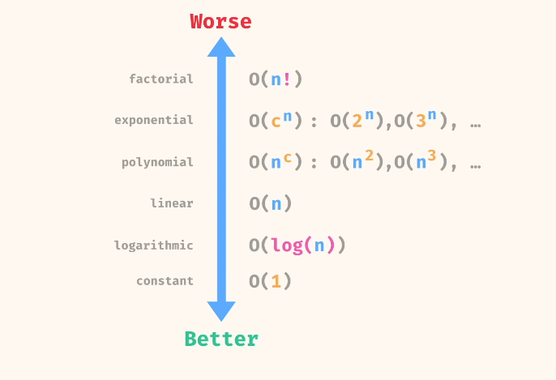

// O(2**n + n**10) -> O(2**n) = here you drop the smaller term and keep the larger term = expontential is worse than polynomial so you keep exponential and drop polynomial

# Big-O Examples

* we are estimating how many operations an algorithm does relative to input size

## Constant time examples O(1)

* initializing a value:
* Mathematic operations (number or boolean operations):

Const a = 4

Const sum = a + 10

Console.log(sum)

* String indexing

Const str = ‘hello’

Console.log(str[1])

* Checking a key exists in an Object

Const stuff = {a:1, b:2, c:3}

Console.log(‘b’ in stuff)

## Linear time examples O(n)

* Checking an array for a value

Const colors = [‘red’, ‘blue’, ‘green’, ‘yellow’, ‘purple’]

Console.log(colors.includes(‘green’)

// it has to iterate through every element of the array

* For loops (single for loops)

Const array = [1,2,3,4,5,6,7]

Let sum = 0

For (let i=0; I < array.length; i++) {

Sum += array[i]

}

Console.log(sum)

* Using the split method

Const sentence = ‘hello world, how are you?’

Console.log(sentence.split(‘ ‘)

// split has to check every character for a space so it is O(n)

* The course will build a sense of time complexity of different built-in javascript methods

## Polynomial examples O(n**c)

* Nested for loops

Const letters = ‘a’, ‘b’, ‘c’, d’, ‘e’, ‘f’]

For (let i=0; i< letters.length ; i++) {

For (let j=0; j< letters.length; j++ {

Console.log(letters[i], letters[j])

}}

// this has a time complexity of O(n**2)

## Time and space complexity of a function

Const function1 = (array) => {

Return array.includes(‘potato’)

}

// length of input: n = array.length

// Time: O(n)

// Space: O(1)

* Another example

Const function2 = (n) => {

For (let I = 0; i< n/2; i++) {

Console.log(i)

}

// time: O(n/2) -> O(n)

// space: O(1)

* If you create arrays or strings that scale, then space complexity would be O(n)

Const function3 = (n) => {

Const nums = []

For (let i=0; i< n; i++) {

Nums.push(i)}

Return nums;

}

Console.log(function3(10))

// time: O(n) -> for loop is O(n) and push method is O(1)

// space: O(n) -> space complexity increases as n increases – it comes from the array that is created

Const function4 = (n) => {

Const nums = []

For (let i=0; i< n: i++) {

Nums.unshift(i);}

Return nums}

Console.log(function4(10))

// time: for loop = O(n), unshift method pushes new value to the front of array and reindexes every value in the array, so it is O(n) -> together they are O(n * n) -> O(n**2)

# Recursion

## What is a recursive function?

* A recursive function is a function that calls itself
* This is in contrast to an iterative function (that runs a for or while loop)

## Example

function countdown(n) {

if (n===0) {

return}

console.log(n)

countdown (n-1); // recursive call needs to bring us closer to the base case

}

* Base case: n=0 ; recursive calls stop and function returns when n=0
* Recursive step: console.log(n); countdown(n-1);
* Ensure that you can hit the base case, otherwise you will get infinite recursion and max call stack size will be exceeded (program will crash as you will run out of memory)

## What if we move console.log(n) after recursive call?

function countdown(n) {

if (n===0){

return;

}

console.log(‘entering’, n);

countdown(n-1);

console.log(‘returning from’, n);

}

countdown(2)

//output ->

//entering 2

//entering 1

//returning from 1

//returning from 2

* Explanation:
  + Countdown(2) runs: it checks the base case, n!==0 so it then runs the console.log(‘entering’, 2) *before the recursive call* and will run print out 2 and then the recursive call countdown(1) will run, *before the ‘returning from’ console.log can run*
  + the next countdown(1) runs; it checks the base case, then runs console.log(‘entering’, 2) and prints out 2, *before the recursive call* and then enters the next recursive call: countdown(0)
  + countdown(0) checks the base case which *returns; as countdown(0) has completed we return back to the first recursive call countdown(1)*
  + countdown(1) can now complete and runs the operation after the recursive call: console.log(‘returning from’, 1) and then exits
  + countdown(1) has exited i.e. it has reached the end of the function and returns to countdown(2)
  + countdown(2) now completes; it runs console.log(‘returning from’, 2), completes and exits